# Snowflake MySQL Connector Load Validations

## Understanding connector status

Once the data source is added and mapped to the target database in Snowflake for replication, we need to add the required tables for the replications so that initial as well as incremental loads can be done.

-- Configuring replication

-------------------------------------------------------------------

-- Adding a data source for replication

CALL ADD_DATA_SOURCE('<data_source_name>', '<dest_db>');

CALL SNFLK_CONNECTOR_FOR_MYSQL.PUBLIC.ADD_DATA_SOURCE('MYSQLDS1', 'MYSQL_SNFLK');

-- Adding source tables for replication

CALL ADD_TABLES('<data_source_name>', '<schema_name>', ['<table_name1>', '<table_name2>', ...]);

CALL SNFLK_CONNECTOR_FOR_MYSQL.PUBLIC.ADD_TABLES('MYSQLDS1', 'src_database', ARRAY_CONSTRUCT('test_tbl2'));

The REPLICATION_STATE view is crucial for monitoring the status of table replication. This process encompasses three distinct phases:

1. SCHEMA_INTROSPECTION: Ensures that the schema of the source table is accurately replicated.
2. INITIAL_LOAD: Transfers the existing data from the source table to the destination.
3. INCREMENTAL_LOAD: Continuously replicates ongoing changes from the source.

Upon successful replication, the status display will resemble the following:

|  |  |  |  |
| --- | --- | --- | --- |
| REPLICATION_PHASE | SCHEMA_INTROSPECTION_STATUS | SNAPSHOT_REPLICATION_STATUS | INCREMENTAL_REPLICATION_STATUS |
| INCREMENTAL_LOAD | DONE | DONE | IN PROGRESS |

# SNAPSHOT_REPLICATION VALIDATIONS

## INITIAL_LOAD

The Source MySQL table has 3 rows initially which can be seen below.

The REPLICATION_STATE view details can be seen below.

Once the INITIAL_LOAD gets completed the phase switches to INCREMENTAL_LOAD which denotes the agent is now monitoring the CDC at the source MySQL database table.

The INITIAL_LOAD can be validated in Snowflake table as seen below.

## INCREMENTAL_LOAD

To validate the INCREMENTAL_LOAD, below are the changes applied to the source MySQL database which can be seen below.

insert into test_tbl2 (random_string, random_number) values ('dj1', 2151);

insert into test_tbl2 (random_string, random_number) values ('dj2', 2161);

update test_tbl2 set random_number=101 where id=1;

delete from test_tbl2 where id=3;

commit;

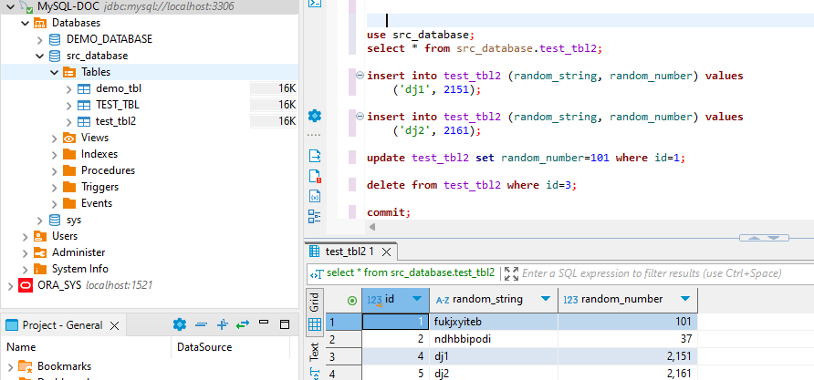

INCREMENTAL_LOAD Validations in Snowflake

The inserts, updates and deletes(soft deletes) are captured in the target Snowflake Table as seen below.

## END